**Code Result**

**Imported Libraries**

Pandas, Numpy, Matplotlib, plotly, Voting Regressor, AdaBoost Regressor, RandomForest Regressor, XGBoost Regressor, train_test_split, GradientBoosting Regressor

**Pre-Processing:**

1. Check Shape of the Data



1. Info

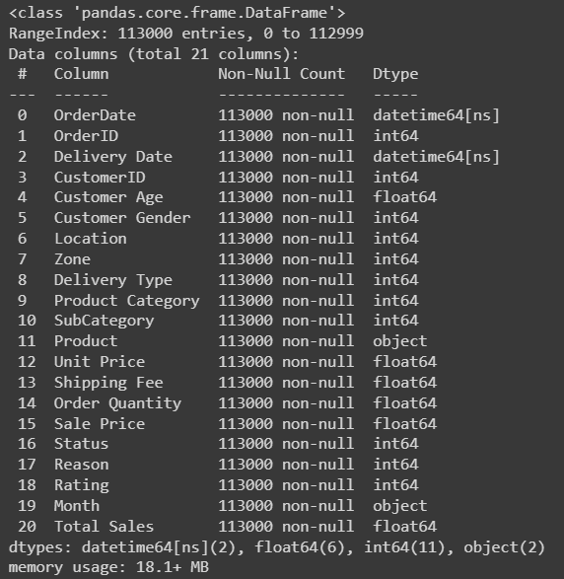

1. Checking Null Values

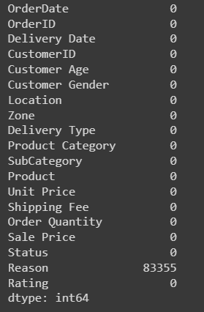

**EDA**

1. Line Plot for Month v/s No. of orders Placed

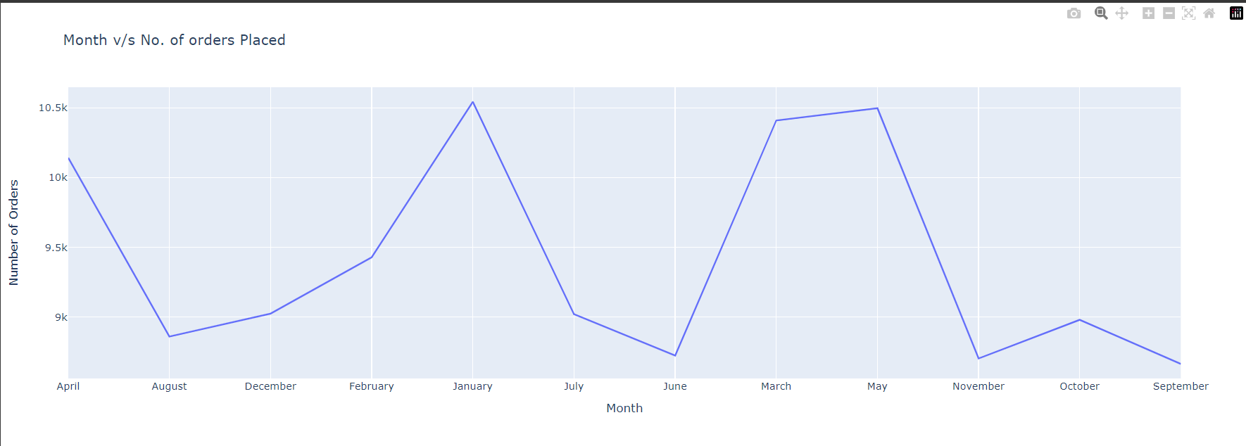

1. A Comparative Analysis of Product Category Preferences Across Different Age Groups and Genders

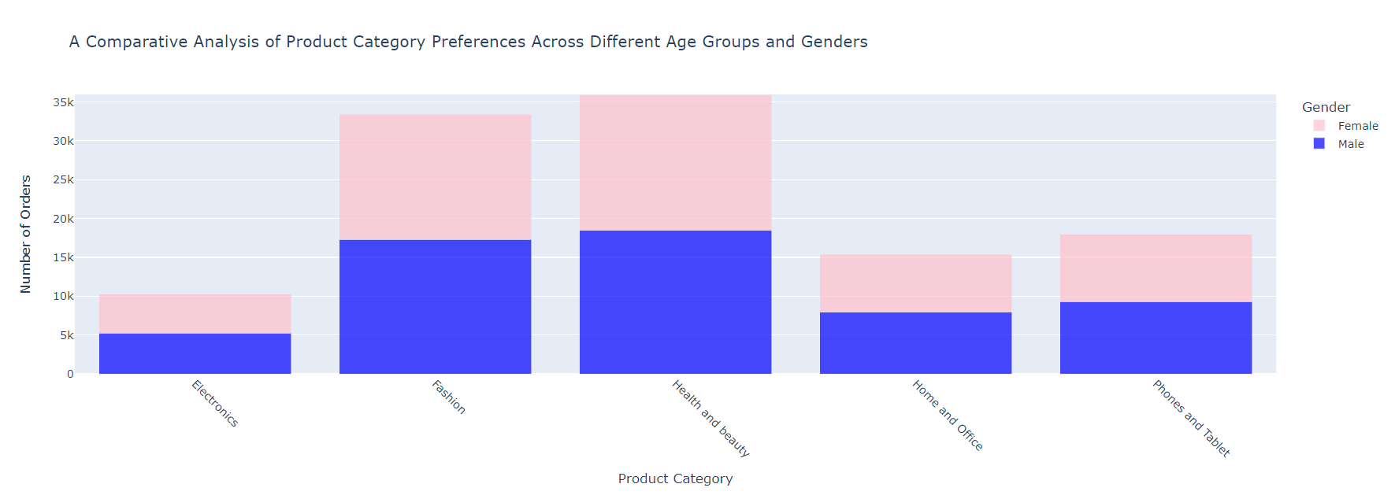

1. Delivery Type Popularity by the Location

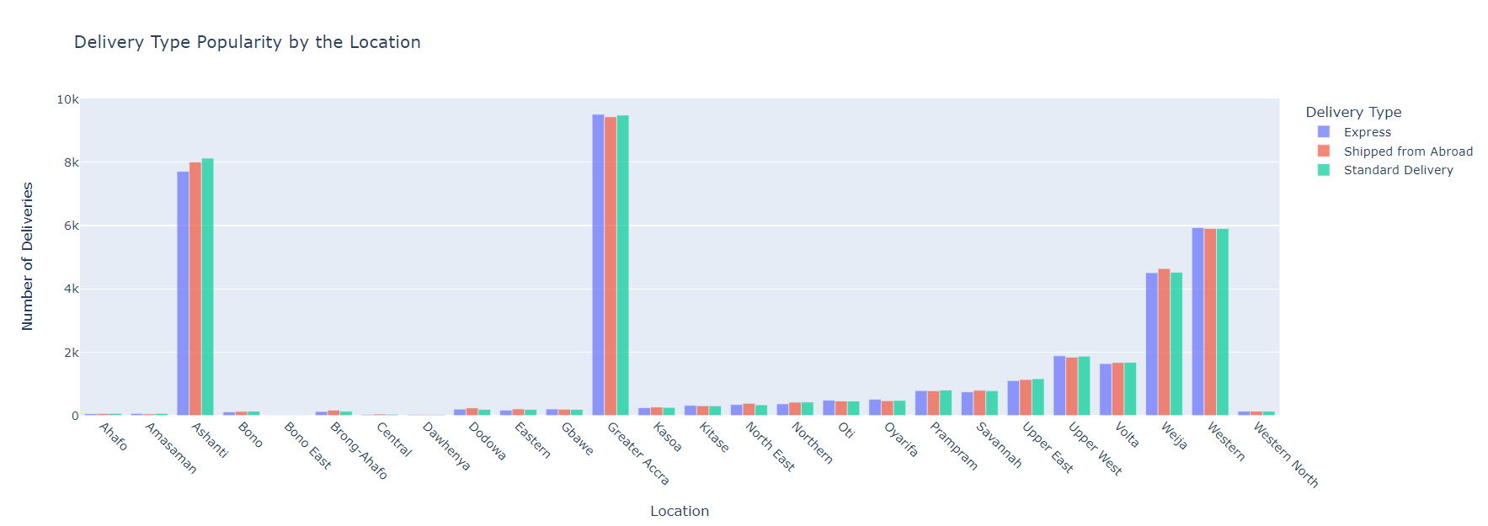

1. Total Sales by Product Category

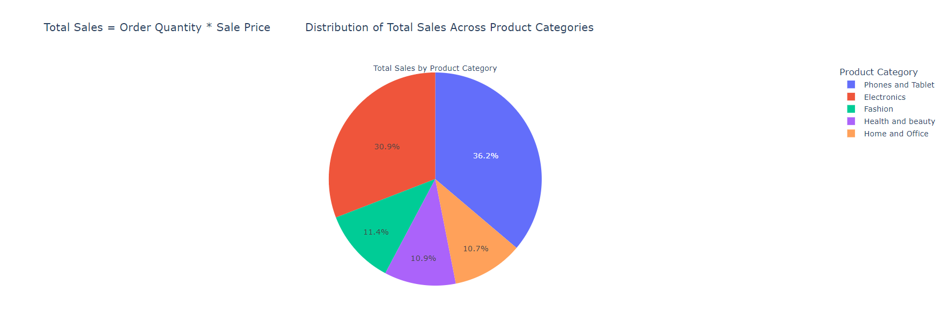

1. Temporal Analysis of Delivery Outcomes: Monthly Distribution of Delivery Status

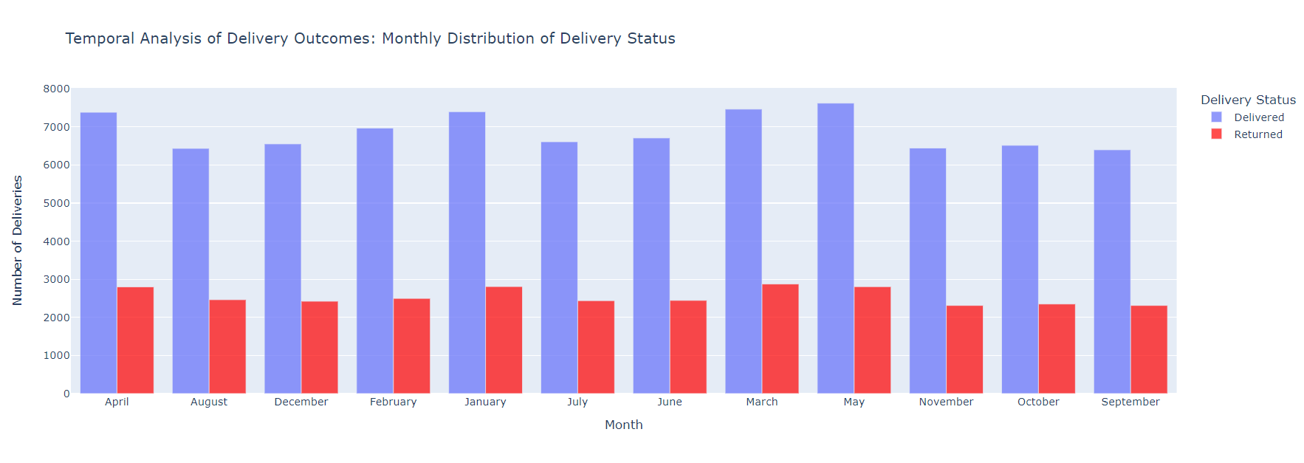

**Train Test Splitting:**

Using the train_test_split function from sklearn to split our dataset into training and testing sets. The test_size parameter is set to 0.25, meaning that 25% of the data will be used for the test set and the remaining 75% for the training set.

x  
For reproducibility, the random state parameter is set to 42. The training and testing sets that are obtained are saved in X_ecom_train, X_ecom_test, y_ecom_train, y_ecom_testfor Y.

**Data**

We apply 3 different Individual Machine Learning Models on our dataset to get the accuracy and after that we make a voting ensemble for these three models

1. Random Forest Regressor

2. Adaboost Regressor

3. XGBoost Regressor

4. Voting Regressor

**Testing and Training results of Random Forest Regressor**

**Training MSE, R2, MAE and RMSE**

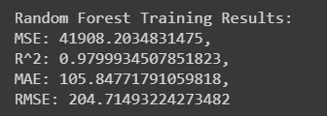

**Testing MSE, R2, MAE and RMSE**

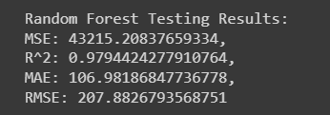

We got 97% testing R2.

**Testing and Training results of AdaBoost Regressor**

**Training MSE, R2, MAE and RMSE**

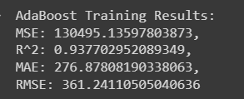

**Testing MSE, R2, MAE and RMSE**

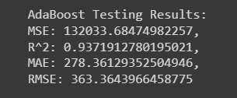

We got 93% testing R2.

**Testing and Training results of XGBoost Regressor**

**Training MSE, R2, MAE and RMSE**

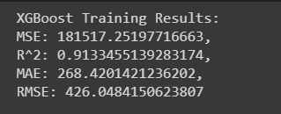

**Testing MSE, R2, MAE and RMSE**

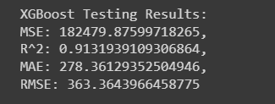

We got 91% testing R2.

**Testing and Training results of Voting Ensemble Regressor**

**Training MSE, R2, MAE and RMSE**

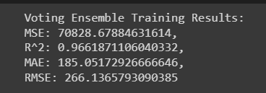

**Testing MSE, R2, MAE and RMSE**

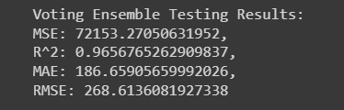

We got 96% testing R2.

**Model Comparison Graphs:**

**1. MSE Comparison Graph**

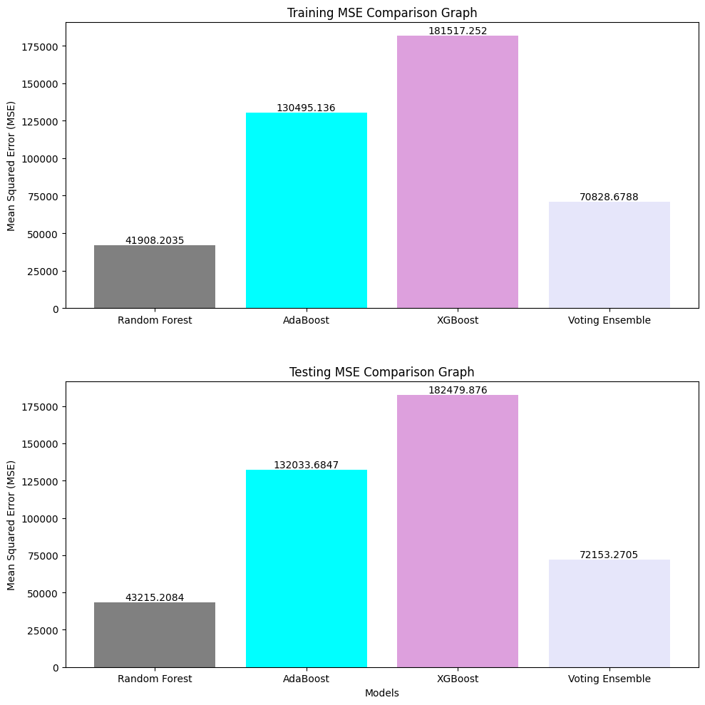

**2. R2 Comparison Graph**

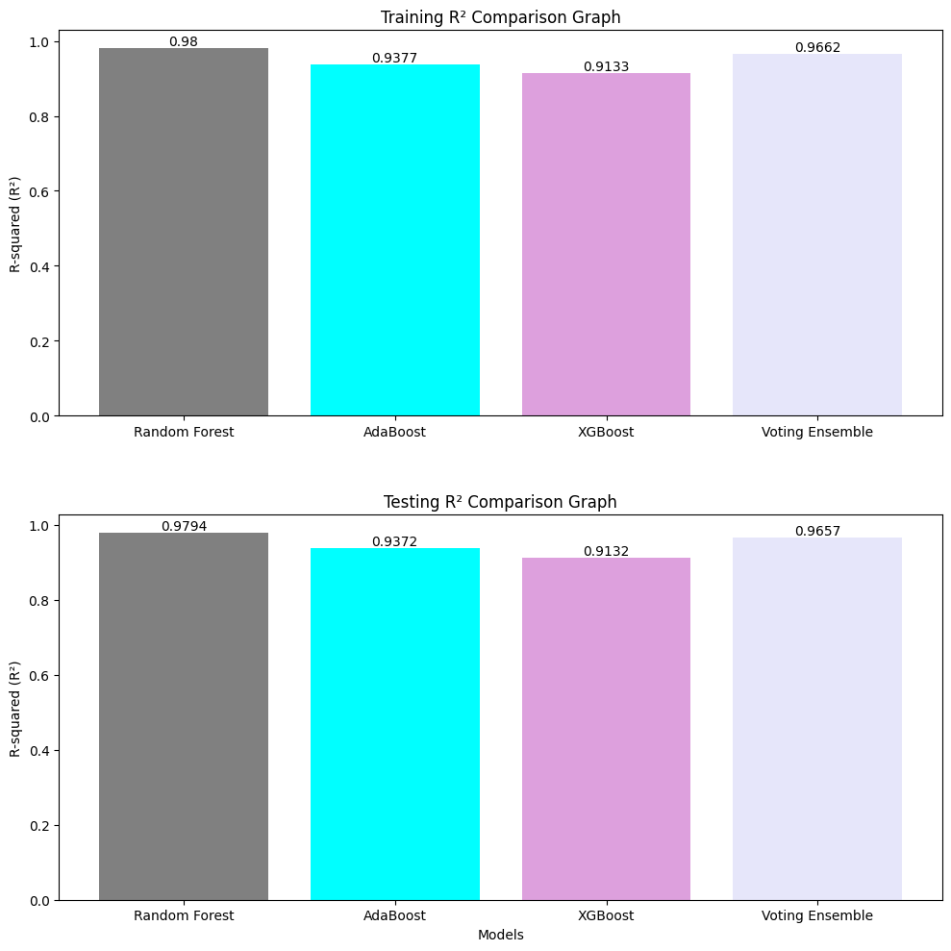

**3. MAE Comparison Graph**

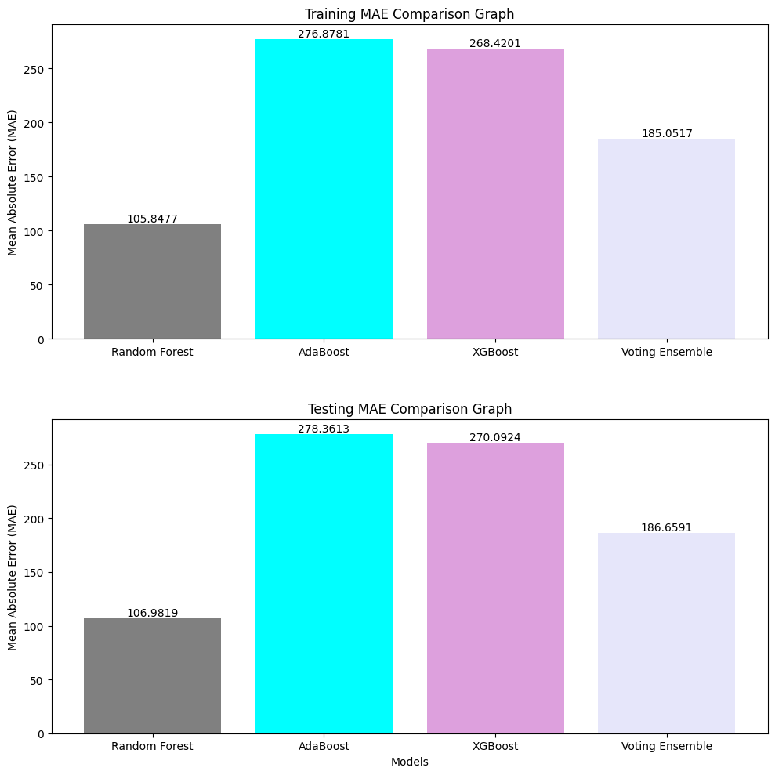

**4. RMSE Comparison Graph**

